Task 2:
#include <stdio.h>

int main() {
int x, y;

printf("Enter first number: \n");
scanf("%i", &x);

printf("Enter second number: \n");
scanf("%i", &y);

printf("(x > 5) && (y < 10) = %d\n", (x > 5) && (y < 10));
printf("(x == 10) || (y == 5) = %d\n", (x == 10) || (y == 5));
printf("!(x == y) = %d\n", !(x == y));

return 0;
}
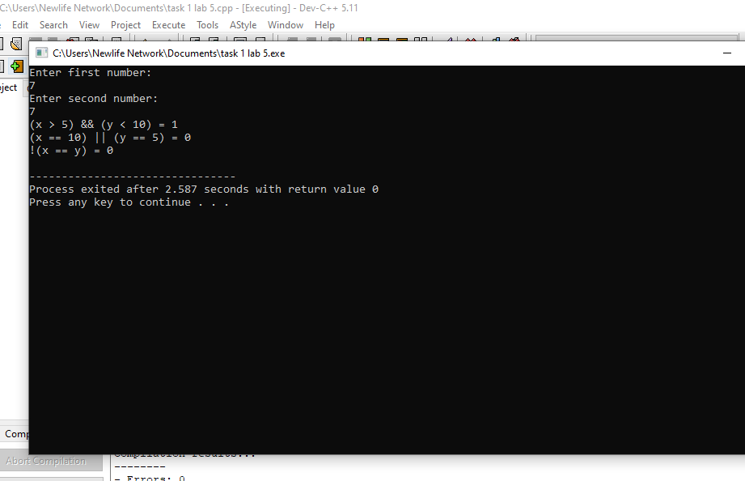

Task 1:
#include <stdio.h>

int main() {
int num1, num2;
float result;

printf("Enter the first number: ");
scanf("%i", &num1);

printf("Enter the second number: ");
scanf("%i", &num2);

result = num1 + num2 * (num1 - num2) / 2;

printf("Answer: %f\n", result);
printf("Step 1: Remove the brackets from num1 + num2 * (num1 - num2) / 2\n");
printf("Step 2: Subtract num2 from num1\n");
printf("Step 3: the result has been divided by 2\n");
printf("Step 4:the result has been multiplied with num2\n");
printf("Step 5: Add num1 to the result\n");

return 0;
}
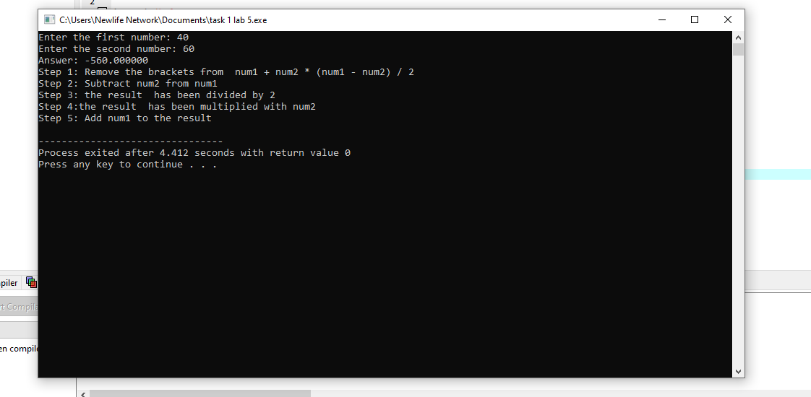

Task 3:
#include <stdio.h>
#include <math.h>

int main() {
int b;
float Answer;

printf("Enter your number: ");
scanf("%d", &b);

Answer = sqrt(b);
printf("Result: %.2f", Answer);

return 0;
}

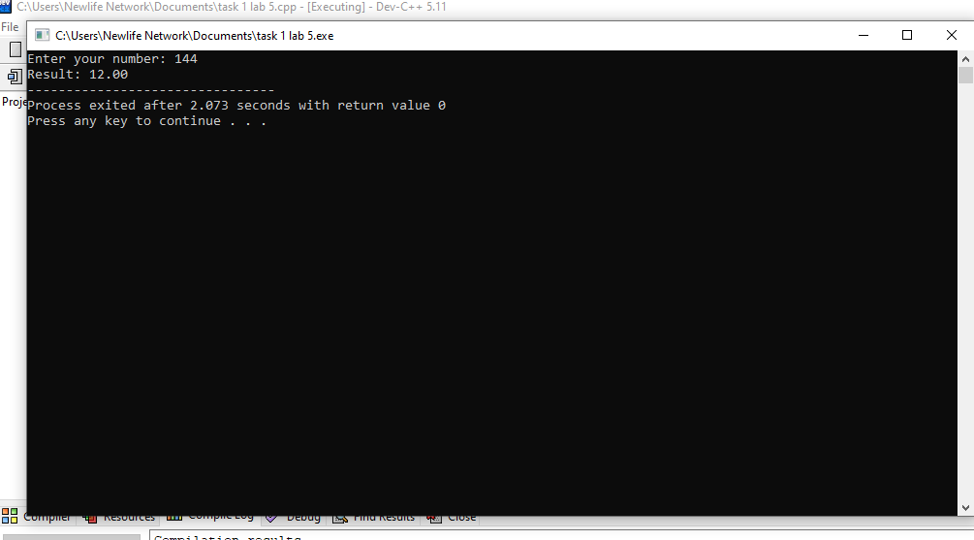

Task 4:
#include <stdio.h>

int main() {
int m, n;

printf("Enter value of m:\n");
scanf("%i", &m);

printf("Enter value of n:\n");
scanf("%i", &n);

(m > n) ? printf("%i is greater than %i\n", m, n)
printf("%i is greater than %i\n", n, m);

return 0;
}
